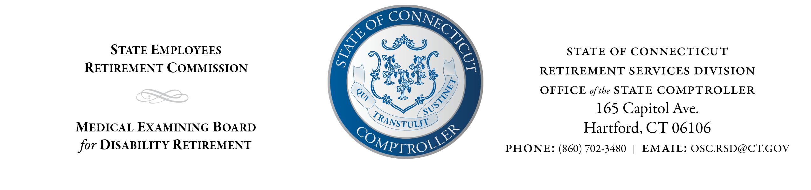
STATE EMPLOYEE RETIREMENT COMMISSION
ACTUARIAL SUBCOMMITTEE

NOTICE and AGENDA
TO: | State Employees Retirement Commission Actuarial Subcommittee
FROM: | John Herrington, Retirement Services Director
DATE: | July 13, 2026
SUBJECT: | Meeting Notice and Agenda
This is to notify you that a meeting of the State Employees Retirement Commission's Actuarial Subcommittee has been scheduled as follows:
DATE: | July 15, 2026
TIME: | 3:00 p.m.
LOCATION: | Teleconference
Join Zoom Meeting
https://us02web.zoom.us/j/86237600329?pwd=c9XFE2sTdxyqebkAXANDAcB6Wjancx.1
Meeting ID: 862 3760 0329
Passcode: 748736
Actuarial Subcommittee to meet to discuss:
- Connecticut State Employees Retirement System Experience Study

